Yards Brewing Variety-Pack Automation
Team 1: Domain Knowledge Project Portfolio
Team Members: Jonathan Alavez Reyes, Faahil Ali, Liya Aji, Margaret Decker, Sabrina Abdukadirova
Course: IT/CPMSC Capstone
Company: Yards Brewery
Date: September 12th, 2026

Table of Contents

Tab Number | Section
1 | Yards Canning Production Line
2 | Yards Variety-Pack Production Process
3 | Yards Variety-Pack Aluminum Can Types & Packaging
4 | High-Speed Cameras & Smart Cameras
5 | OpenCV for Image Defect Detection
6 | Ideas for Prototype & Solutions
7 | Supporting Notes & Documentation

TAB 1: Yards Canning Production Line
Initial Yards Brewery Visit Audio/Video Transcripts
Audio File # 9 (17 minutes): Overall Can Production Process
- Beginning of the Can Line
  - (3:01) The facility separates its production areas: the left side is bottling and the right side is canning.
  - (3:06) The canning process begins with full pallets of cans. Damaged or broken cans are manually removed from the pallets.
  - (3:52) A chain-and-pulley system lifts the pallet and positions the slip sheet so cans can be pushed onto the conveyor.
  - (4:05) Loose or falling cans are collected and moved toward a single-file conveyor system.
  - (4:14) A device called the “KK can slide” helps move cans into the proper position. Removing damaged cans directly from the palletizer could also be a potential inspection point.

- Can Handling and Inspection
  - (0:56) Pallets of cans are loaded into the production line, unloaded, and sent through a rinser.
  - (1:00) The rinser twists the cans. Damaged or bent cans can become jammed or wedged in the machine, which can help identify defective cans.
  - (1:19) After filling, an X-ray inspection system checks the cans for proper fill height and verifies that the lid/end has been applied.
  - (1:27) Ideally, there would be more time for a leaking can to show a low fill level before inspection. More advanced systems could also check for internal pressure or wedge damage, but these systems can be expensive.
  - (1:44) Because of equipment and cost limitations, the brewery focuses on ensuring the fill height is correct and relies heavily on operators to visually identify problems.

- Automation and Sensors
- (6:47) The control system monitors the amount of can accumulation on the conveyor and can stop equipment upstream or downstream when necessary.
- (7:08) A proximity sensor and bump bar detect when too many cans have accumulated. When the cans push the bar, the sensor detects that the area is full.
- (7:17) The automation system can shut down equipment when necessary to prevent jams and equipment damage.
- (7:26) Different sections of the conveyor could potentially be used as locations for detecting damaged cans.

- Can Rinsing and Product Coding
- (7:40) The cans go through an ionized-air rinse. The cans are flipped upside down while ionized air blows dust out and a vacuum removes it.
- (8:03) While the can is upside down, a product code is applied for traceability and production identification.
- (8:10) The X-ray inspection system checks the can and uses sensors to determine whether the lid/end is present.
- (8:20) The system checks the fill level. Cans with an incorrect/low fill level are automatically removed from the production line using a pneumatic punch.
- (8:29) Test cans are kept nearby to verify that the inspection system is working correctly.
- (9:11) Another high/low sensor checks the position of the can. If a can is not detected correctly, an air blast can remove it from the line.

- Filling the Cans
- (11:13) Beer travels through a flow meter and enters the cans using laminar flow, which allows the beer to flow smoothly down the sides of the cans.
- (11:22) CO₂ is used during the filling process because oxygen is a major concern and needs to be removed from the can.
- (11:41) The cans are pre-flushed with CO₂ to remove air before being pressurized and filled.
- (11:51) After the can is pressurized, beer is added while the system carefully controls the pressure.
- (11:59) Pressure is gradually released so the beer does not overflow or “boil” out of the can. The goal is to produce a controlled foam cap.

- Can Lid Application and Seaming
- (12:24) The undercover gasser and steamer prepare the can for sealing. CO₂ is used to create a protective blanket over the beer before the lid is sealed.
- (12:49) The can goes through two main seaming operations: first, the can is positioned and bent around the flange, and then the seam is formed.
- (13:06) The can spins at approximately 4,500 RPM while the seaming process forms the connection between the lid and can.
- (13:15) This process is called a Pittsburgh roll and has been used for approximately 100 years. The seam is formed through multiple points of contact.

- Removing Water and Condensation
- (13:33) After filling and sealing, water is used to remove excess foam and liquid from the cans.
- (13:54) The process also removes/shears off condensation from the outside of the cans.
- (13:58) Some breweries use a can warmer, similar to a small tunnel pasteurizer, to bring the can closer to its dew point and prevent condensation.
- (14:11) Reducing condensation helps prevent moisture from damaging or deforming the cardboard packaging.
- (14:17) Since this facility does not use a can warmer, it removes as much excess liquid as possible before labeling.

- Can Coding and Identification
- (14:26) The cans are marked using a continuous inkjet printer rather than laser etching.
- (14:46) The printed information includes a batch code, followed by the production date and time.
- (14:55) Different customers/contracts may require different types of date codes, such as a sell-by date or Julian date.

- Conveyor Controls and Production Speed
- (15:20) Motors throughout the canning line can be controlled independently, allowing operators to adjust the speed of different sections.
- (15:27) Adjusting conveyor speeds can help create separation between cans and improve the flow of the production line.
- (15:42) The line is currently operating at approximately 220 cans per minute.
- (15:51) The labeling system was operating at approximately 218 cans per minute to create enough accumulation and maintain a single-file flow.

- Labeling
- (16:09) Normally, a large roll of labels feeds through rollers and into a peel plate.
- (16:15) As each can passes through, the machine removes a label from the roll and applies it to the can.
- (16:24) Operators visually inspect the labels to make sure they are properly positioned and square.

- Overall Can Production Process:
  - Step 1: The cans come together and make a single file line.
  - Step 2: The cans turn upside down via Invertor #1 and while they are turned over, the cans get ionized with air or C02 to get the debris out of the can.
  - Step 3: The can gets a product code put on the bottom and Invertor #2 puts the can straight again.
  - Step 4: The cans go through High/Low Sensors to make sure everything looks correct, and there is a lid.
  - Step 5: Then, the cans get filled with CO2 first, then beer, then sealed shut.
  - Step 6: The sealed cans go through the X-ray machine to make sure they are filled properly and to check for damages.
  - Step 7: Then, the cans are put into a machine to pack it into 6-packs, 12-packs, etc.
  - Step 8: Then a worker packages up the packs of beer manually.

TAB 2: Yards Variety-Pack Production Process
Initial Yards Brewery Visit Audio/Video Transcripts
Audio File #11 (7 minutes 13 seconds): Variety-Pack Process
- Current Packaging Process
  - (0:00) The current process uses manual glue guns and a conveyor system with chutes on both sides. Workers manually open cases and load the cans onto the conveyors.
  - (0:10) Empty cases are returned to the top of the system, where they come down to the end and are repacked by workers.
  - (0:14) The current system was developed through a Kaizen event, which brought employees from different departments together to improve the process.
  - (0:58) Some parts of the process, such as gluing boxes, could potentially be automated, although workers would still need to open and load the boxes.
  - (1:06) The current operation ideally requires about five workers: workers to open and load cases, workers to reload cans into boxes, and someone to glue the boxes closed.

- Variety Pack Process
- (2:11) The process is designed for variety packs, where multiple beer brands or flavors are combined into one box.
- (2:26) For example, a 12-can IPA variety box may need to contain four cans of each of three different products.
- (2:37) The different products are first packaged separately and then brought to different conveyor lanes for sorting and combining.
- (2:47) A small variety stitch is used on the boxes so they can be easily opened and the cans removed.
- (2:57) Workers currently shovel the cans from the opened boxes onto a running conveyor.
- (3:01) The system can handle up to four different flavors/products, with each product traveling in its own lane.
- (3:11) The cans must then be reloaded into the box in the correct configuration for the variety pack.

- Configurable Variety Pack System
  - (4:29) The system needs to be able to arrange different quantities of cans depending on the variety-pack configuration.
  - (4:40) Some packages use a 3-by-4 configuration, while others use 4-by-4 or 2-by-6 configurations.
  - (4:49) Because the brewery frequently uses different configurations, the automated system should ideally be configurable for different pack sizes and arrangements.
  - (4:53) The current operation commonly uses three- or four-product configurations, while another product uses a two-product configuration.

- Project Development and Testing
- (5:13) The variety-pack automation idea could be an interesting project because the team could have a dedicated area to develop and test the system without interfering with normal production.
- (5:33) The team could develop its own solution, with experienced employees available to provide advice, technical knowledge, and information about how the current process works.
- (5:47) The team should consider the current cycle time and production performance when designing the automated system.

September 4th, 2026: On-Site Visit Transcript Notes

Five-Person Manual Process
- "You said there were five people for the variety pack process."
- "That was typical, yeah."
- "You'll have typically two down here and three down here."
- "Sometimes they try not to stay up over five."
- "Each operator has to grab a gun, put four dabs of glue, count to three, and then stack it."
- "That's another manual process."

12-Pack Requirement
- "It all has to be 12 cans though, right, in a variety pack?"
- "Yes."
- "They would take them out, open them up, and then they just slide the cans out of the boxes and put the empty 12-packs back in the tray."
- "We'll reuse those same boxes to have a mixed data pattern."
- "It's always 12 for variety."
- "For the Yards brand, we're currently just doing the three flavors for the cans and then for the bottles, there's four flavors into the 12-pack box."

Quality / Counting as the Major Concern
- "Quality is somewhat of an issue there."
- "If you load the lanes wrong, you're landing the wrong product down."
- "If you're not paying attention, you're grabbing, you can double grab one product and fill in the box."
- "You could potentially short it."
- "Someone will be here talking to the other person and not realize that they reached in the wrong lane and they've doubled down on the lane."
- "This case is going to get two rows of pale ale and a row of filthy, but it should have gotten filthy pale ale and gold."
- "How are you guys normally catching those errors?"
- "We aren't."
- "There's really no way to know other than when the customer complaint comes in."
- "The problem is on the Yards brand products, we're managing that."
- "When we're doing contract, you've got to be really accurate with that."
- "The biggest mistakes would happen down there."
- "Another mistake that can happen is somebody doesn't do the correct order."
- "If somebody accidentally puts five of one flavor, then you're off."
- "It also throws off our counts."
- "We may have to spend time rectifying the damage that's left over."
- "We try to keep double-check if there's so many layers."
- "Each of your staged palettes, so single flavors, should balance out."
- "We should have it balanced down there at the finished product."

Variety Packs Done Separately from Normal Canning
- "The thing is, this stuff is done a separate day."
- "We can only package each one."
- "These are the three flavors for the variety pack."
- "We can only package one flavor at a time on the can line."
- "All this work gets done a separate day."
- "It's always work that's got to be done at only our date."
- "Can't do it at the same time."

One Flavor Packaged at a Time
- "I usually run one to two SKUs per day out of this line."
- "You're doing red one day, blue one day, green one day?"
- "You could say that, yeah."
- "We can only package one flavor at a time on the can line."
- "When the beers, like an individual flavor is packaged on the line, it just goes into a full box."

Mixing and Resealing Being Difficult
- "Mixing and resealing would be the most difficult thing."
- "You have to open them up, take them out, and then they have to be stuffed in."
- "We do a special glue process when we're doing variety on the box."
- "It's a minor amount of glue during the actual run on those cases so they're easy to open."
- "You get a better sealed glue with the hot glue gun."
- "The slowest part is probably doing the gluing, stuffing and gluing."
- "You've got to be careful."
- "It's more manual work, so that's where mistakes could happen."

Shuffling Trays Being Easier
- "Shuffling the beer onto the trays is the easiest thing."
- "You just put it on there."
- "Someone is putting them in the conveyor belt."
- "This is easier."

Double-Check / Balance Process
- "Recently, what we've been doing or implementing is we try to keep, double-check if there's so many layers."
- "Each of your staged palettes, so single flavors, should balance out."
- "There's 10 cases on the layer."
- "We should have it balanced down there at the finished product."
- "Let's just set a certain amount that we want to complete before anybody walks away."
- "When we're done, just check at the end and see that we're close to being balanced."
- "Once they think they're done, we just double-check to make sure that all the flavors are correct."

Variety-Pack Machine Being Movable
- "All of this can be moved, right? Because I see it has wheels on it."
- "Yeah, yeah."
- "This is for the bottles."
- "This would go in the middle, so we just swap them out."

Can Damage Occurring During Manual Handling
- "Does it happen that cans get damaged when they reach the end?"
- "It's mainly just handling."
- "It's either here or if someone has to manually stuff them back into the 12-pack boxes."
- "The more people that handle something physically, that's where the damages could occur."
- "You could easily pull one out of a box and one could fall and get dented."
- "Cans, it doesn't take much to dent a can."
- "For whatever reason, like it might have been a leaker or something bad, they just get rejected."
- "We write it off."
- "We'll replace it with some from our sample lot."
- "Like, somebody drops one and it gets damaged."
- "Now your count's off."

Zoom Meeting with Yards — Meeting Notes
Current Production Volume
- "Current volume is approximately 1,500 cases per day."
- "This is when they use the machine the way it needs to be used."
- "With a couple of people, production typically mixes 150 to 200 cases."

Current Staffing / Production Rate
- "The amount of people varies depending on the process and level of automation."
- "This makes it difficult to tell us the exact amount of volume or speed."

Current Variety-Pack Workflow
- "Current volume is approximately 1,500 cases per day."
- "With a couple of people, production typically mixes 150 to 200 cases."
- "Diesel: Discuss how the random variety-pack process currently operates."
- "Neal Idea: Cans move through two sets of escapements."
- "Escapements would separate and count the required package quantity."
- "After separation, products would be transferred into the carton."
- "Process would move from full accumulation to organized separation before loading."

Current Manual Labor
- "The amount of people varies depending on the process and level of automation."
- "With a couple of people, production typically mixes 150 to 200 cases."

Current Errors
- "Consider tying the system into a conveyor shutdown mechanism if the can falls down."

Quality-Control Concerns
- "Track which lane an issue occurs to make it easier to tell which lane the problem is in."
- "Verify arrangements using a camera."

Need to Identify Which Lane Has an Error
- "Track which lane an issue occurs to make it easier to tell which lane the problem is in."

Current Spacing / Layout Information
- "Distance between gates and carton loading area is approximately:"
  - "2 feet (needs to check this)"
  - "60 inches across the conveyor"
- "Want a dead plate + side discharge for pusher."
- "2ft-16inch max."
- "Review layouts similar to case erector."
- "A side-view diagram may be more useful than a top-down layout."

Variety-Pack Scheduling
- "Determine which production days of variety packs are packaged."
- "Then decide on a meeting date for that."
- "Diesel: Discuss how the random variety-pack process currently operates."

Switchback Discussion
- "Investigate the Switchback line operation."
- "Neal mentioned it runs Tuesday through Friday."
- "Could be useful reference material for building a prototype."

Summary of Problem Points in Variety Process
Problem point | Evidence from Yards | Project significance
Wrong variety combination | Employees can reach into the wrong lane, double-grab one product, or short another. Yards often cannot detect the mistake until a customer complains. | This is the primary target as the system needs to prevent or detect mix errors.
No closed-loop verification | Current checks are largely balanced/eyeball/manual-count based. | Creates an opportunity to put in cameras to count cans and use sensors to look at the color of cans.
Can damage | Cans can be dropped or damaged during lane loading and handling; damaged product is written off. | Guides, gates, and loading mechanisms need to avoid denting and unstable impacts.
Manual loading into reused carton | Cans need to be side-loaded/stuffed into the reused 12-pack; this is less forgiving than top-loading bottles. | Significant mechanical challenge for us
Mixing + resealing | Site notes identify mixing and resealing as difficult manual portions. | Sealing is relevant but can be kept downstream/manual.
Variable staffing / intermittent use | Variety work is often done after main work orders, during changeover, or with ancillary labor. | The design should be simple, modular, and useful even when the station is not always staffed.

Initial Drawing of Variety-Pack Process from Yards Brewery Visit Videos:
- Talks about the five-person manual process, separate variety-pack can lanes, reuse of package boxes, manual can mixing, sealing, and pallet movement.
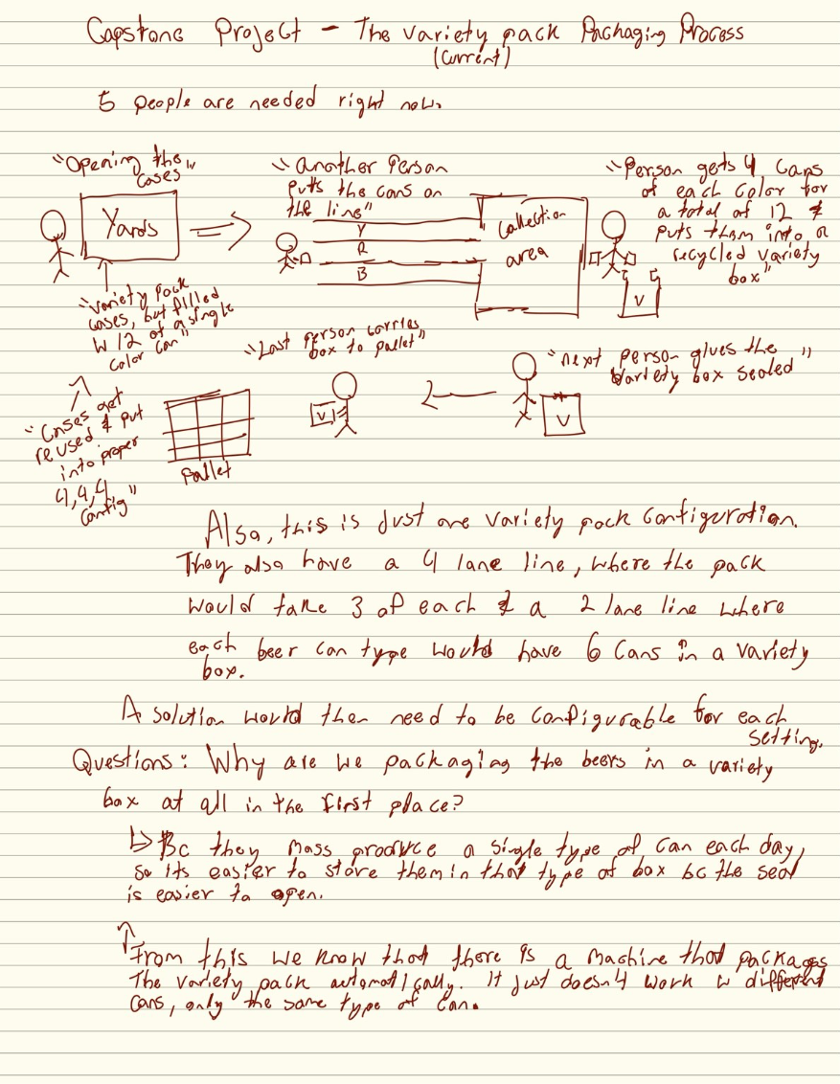

Drawing of Yards Variety-Pack Process from September 4th On-Site Visit:
- It shows the shared conveyor, multiple lanes, end of lane, backfill region, preparation areas, and packaging at the end of the station.
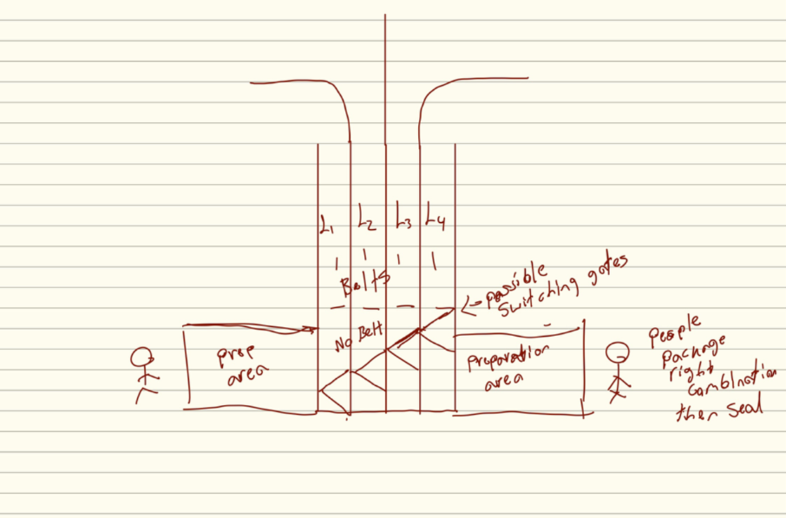

TAB 3: Yards Variety-Pack Aluminum Can Types & Packaging

Purpose of This Tab
This section defines the physical product and packaging characteristics that directly affect the automation design. The general canning process is covered in Tab 1. This tab focuses specifically on what the variety-pack machine must physically handle.

Current Variety-Pack Product
Yards produces its individual beer SKUs separately because the main canning line normally runs one or two SKUs per day for efficiency. The existing packaging equipment is designed to create uniform packages of one SKU. Variety packs are therefore assembled later by reopening previously packaged products, separating the different flavors, and recombining them into a mixed package.
For Yards' current canned variety pack, the finished package contains 12 cans total. During the September 4 visit, Yards confirmed that its current Yards-branded canned variety pack uses three flavors, with four cans from each flavor.
The current standard arrangement is therefore:
Flavor A: 4 cans
Flavor B: 4 cans
Flavor C: 4 cans
Total: 12 cans
Yards has also used other configurations. The system historically supported four-product configurations, and a current contract product uses two flavors. Therefore, although the immediate prototype can focus on the current three-flavor configuration, the design should remain modular enough to support different recipes.

Fixed Flavor Lanes
Different products are loaded into separate conveyor lanes before the manual mixing operation. For the current Yards configuration, three lanes are useful for the three active flavors. The physical equipment contains another lane, but it is not currently required for the standard Yards three-flavor can variety pack.
This fixed-lane arrangement is important because the system can associate each lane with a known flavor rather than requiring the camera to identify every individual can before it is dispensed.

Reused 12-Pack Cartons
Yards does not normally discard the original 12-pack cartons during variety production. The cartons are intentionally given a lighter "variety stitch" during the initial packaging operation so that employees can later reopen them without badly destroying the carton. The cans are removed, mixed into the required configuration, and then placed back into the reused package.
The cartons travel down a gravity-fed return track so they can be retrieved at the packaging end of the variety line.

Carton Loading Orientation
The cans are side-loaded horizontally into the reused carton. They are not dropped into the package from above. This distinction is important for the automation design because the machine must horizontally transfer a grouped set of cans through the open side of the carton.
The cans therefore need to remain aligned during insertion so that they do not:
- catch on the cardboard opening,
- tip,
- spread apart,
- or become dented.
The current design direction uses thin stainless-steel guide plates around the loading region to help maintain alignment during this transfer.

Can Handling and Damage
Aluminum cans are relatively easy to dent during manual handling. Yards reported that damage is most likely to occur when employees physically handle the cans, remove them from boxes, place them onto the line, or manually stuff them into the reused cartons.
For that reason, the automation should minimize:
- drops,
- hard impacts,
- sharp contact surfaces,
- uncontrolled collisions,
- excessive side pressure.
Any gate, guide, or pusher that contacts the cans should distribute force across a reasonably broad surface.

Packaging Constraints That Drive the Design
Constraint | Design impact
12 cans per finished pack | System must verify 12 total cans
Current Yards recipe = 4+4+4 | Three active flavor inputs required
Other recipes may exist | Recipe/configuration must remain adjustable
Aluminum cans dent easily | Controlled low-impact movement required
Carton is reused | Machine must tolerate some carton variation
Carton opens from one side | Horizontal loading required
Cans are side-loaded | Guides/pusher need to maintain row alignment
Lane identifies flavor | Vision does not need to be primary SKU-tracking method

TAB 4: High-Speed Cameras & Smart Cameras
The primary role of the camera in the variety-pack system is to independently verify that the correct visible can colors/SKUs are present before the completed group is pushed into the carton. The camera acts as a quality-control fail-safe rather than the primary mechanism used to count and dispense the cans.

Recommended Camera
The camera best suited for the task of registering beer can color and SKU information is the ELP High Speed Global Shutter Camera. The camera price point is a little over 100 dollars (currently 110$ on Amazon). This will do the job we need it to do without sacrificing budget to get a higher-grade camera than we need. The ELP camera shoots at 80-200 frames per second depending on the quality picture we want. The zoom on the camera lens goes from 2.8mm to 12mm and can be adjusted manually. Notably, this is not a smart camera. Image processing will be done externally. Because the camera is high-speed, it will be able to capture color and SKU numbers without any blur or smudging on the pictures.

Frame rates available on ELP’s camera which shoots at 2.0 MP (megapixels):
- MJPEG 200fps at 1280x720
- YUY2 200fps at 1280x720
- MJPEG 120fps at 1920x1200 / 1080P
- YUY2 80fps at 1920x1200 / 1080P
*Note: YUY2 is a less compressed video format than MJPEG— usually better-quality frames but it takes up more space and bandwidth (Cute Digi).

CMOS stands for “Complementary Metal-Oxide-Semiconductor". It is a type of sensor used by cameras to take a picture by turning captured light into digital data. Global-shutter CMOS means each pixel in a given frame is captured at the same time. This means very little distortion or motion blur, which we want to avoid as the cans are moving.
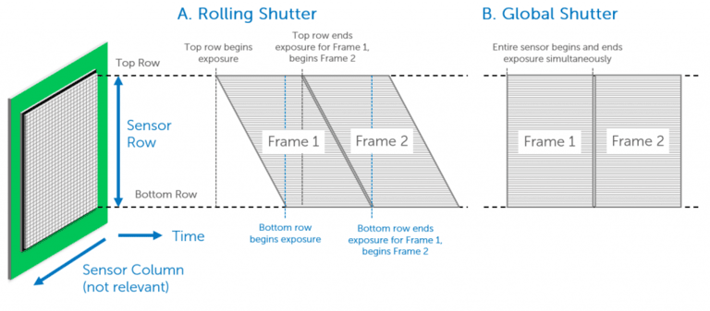Figure from Teledyne Vision Solutions, displaying the difference between a rolling shutter and a global shutter.

Other Hardware
We will need a permanent light fixture, as a high shutter speed means less light captured by the camera (in essence, the more light, the better). Light will likely need to be attached to either the camera apparatus or the machine itself to ensure as little movement as possible to keep captures consistent. A ring light is an inexpensive and easy option, although charging would need to be dealt with, which could inconvenience staff. Speed lights, which are essentially a more powerful, attachable flash alternative, could be useful in this case, although these are also battery-powered. Industrial level high-intensity lighting may seem like overkill, especially with a smaller budget, but these provide the best continuous flash. A light like the LM45 Mini Linear Light would fit this bill. This light also has diffusing and polarizing, which widens the angle of light emission and reduces glare, respectively. It also has an option for continuous light and strobe lighting, which makes it versatile.
Along with a light fixture, the camera will need some sort of mount to keep it both stable and out of the way during use. Mounts are readily available on the market, however, the team could also see what Yards can provide if they have a solution on site. This would need to be something that, while sturdy, is adjustable if the company ever decided to reorganize or move things around. A clamp would be a good way to keep the camera stable but also allow for readjustments in the long run.

Can Inspection
In terms of inspecting the cans, we plan to have the camera facing down from the top, in order to best collect data from all twelve cans moving into the box. This way, none of the cans are blocking each other from view. We will have to figure out the limitations of how easily the colors can be picked up from the top down, so this will require more testing as we get further along in the process. We plan to use either a Raspberry pi or Arduino to analyze the information provided by the camera and send an output should the cans be out of place, ideally to a blinking light that would alert staff to the issue.

TAB 5: OpenCV for Variety-Pack Color & Configuration Verification

OpenCV and Its Purpose in Our System
OpenCV, which stands for Open Source Computer Vision Library, is a software library that provides tools for processing and analyzing images and video. For our project, OpenCV would be used to process the images coming from the camera discussed in Tab 4 and determine whether the correct combination of cans has been created before those cans are pushed into the variety-pack box.
The camera would not be the main system responsible for counting and dispensing the cans. That responsibility would primarily belong to the gates/escapements and their corresponding sensors. Instead, the camera and OpenCV would act as an independent quality-control layer. This gives us a way to verify that what the mechanical system believes it created is actually what is physically present before the cans are loaded into the box.
This is especially important because one of the main problems identified by Yards is that the current process has no reliable way of knowing whether the correct combination was placed into a box. An employee can accidentally grab too many cans from one lane or not enough from another, and the mistake may not be caught until a customer opens the package.
For example, if the current Yards variety pack requires:
4 cans from Lane 1 + 4 cans from Lane 2 + 4 cans from Lane 3 = 12 cans
The mechanical system would first attempt to create that configuration. The vision system would then independently inspect the group and determine whether the visible cans match the expected 4-4-4 combination.
If they do, the system can allow the loading process to continue. If they do not, the system can prevent the pusher from operating and alert an employee that something needs to be checked.

Why We Are Using OpenCV Instead of Starting with an AI Model
Our first approach should not require training an AI or machine-learning model.
The main question that we are trying to answer is relatively straightforward:
Are the correct number of cans from each expected variety present before the case is loaded?
The cans used for the variety pack have visual characteristics that can potentially be distinguished based on their colors. Because of this, we can first test whether traditional computer-vision techniques are enough to identify and count the different varieties.
OpenCV already contains tools that allow us to separate parts of an image based on color, locate objects inside those separated areas, measure those objects, and count them. This would make the first version of the system much simpler to develop and understand than a trained machine-learning model.
If testing later shows that color alone is not reliable enough because of reflections, similar package designs, lighting changes, or other issues, then a more advanced model could be considered. However, we should first test the simplest method that can reliably solve the problem.

Proposed Image-Processing Process
The overall vision process would work as follows:
- The mechanical system creates the requested group of cans.
The gates/escapements separate the expected number of cans from each active lane.
- The cans reach the inspection position.
Before the loading mechanism pushes the cans into the carton, the group is held in a known location where the camera can see it.
- The camera captures an image.
The image should contain the entire group of cans that is about to be packaged.
- OpenCV isolates the part of the image that contains the cans.
We do not need to process the entire camera image if only one known section contains the product. Limiting the analysis to this area reduces unnecessary information and makes the system more consistent.
- The image is converted into a color format that is easier to analyze.
- OpenCV creates separate masks for each expected can color.
For example, one mask may identify red cans, another blue cans, and another green cans.
- The masks are cleaned if necessary.
Small reflections or isolated pixels can be removed so that they are not incorrectly treated as cans.
- OpenCV identifies the individual can regions inside each color mask.
- The system counts how many valid cans belong to each color.
- The detected counts are compared with the selected recipe.
- The vision system returns either PASS or FAIL.
- PASS allows the loading mechanism to continue. FAIL stops the loading step and alerts the operator.
The important part of this design is that the camera analyzes the image and turns it into information that the rest of the automation system can use.

Comparing the Detected Cans with the Recipe
Once the system determines how many cans belong to each expected color, the results can be compared directly with the recipe selected by the operator.
For example:
Selected Recipe
Lane 1 / Red: 4
Lane 2 / Blue: 4
Lane 3 / Green: 4
Total: 12
OpenCV Detection
Red: 4
Blue: 4
Green: 4
Total: 12
Result: PASS
The control system could then enable the pusher and allow the cans to be loaded.
If the image instead produced:
Red: 5
Blue: 3
Green: 4
Total: 12
the total number of cans is technically correct, but the variety configuration is wrong.
The result should therefore be:
Result: FAIL
Expected Blue: 4
Detected Blue: 3
Expected Red: 4
Detected Red: 5
Pusher disabled
Light Turned on
This situation directly represents one of the human errors that Yards currently experiences. The goal is not simply to know whether twelve cans are present. The system needs to know whether the correct twelve cans are present.

Relationship Between the Mechanical System and OpenCV
The mechanical and vision systems should support each other rather than depend completely on one another.
The double-gate/escapement system should know how many cans it has attempted to release from each lane.
For example:
Mechanical System Reports
Lane 1: 4
Lane 2: 4
Lane 3: 4
The camera then independently checks what physically ended up in the staging/loading area:
Vision System Reports
Red: 4
Blue: 4
Green: 4
If both systems agree, we have much stronger confidence that the case is correct.
If they disagree, something unexpected happened between dispensing and loading.
This could indicate:
- a can became stuck,
- two cans passed unexpectedly,
- a can fell,
- the wrong flavor was loaded into a lane,
- or the camera could not confidently recognize a can.
Instead of allowing the system to continue anyway, this disagreement becomes a fail-safe condition.

Lighting
The OpenCV software will only be as consistent as the images that it receives.
The aluminum cans are reflective, and their appearance can change depending on:
- overhead plant lighting,
- reflections,
- shadows,
- time of day,
- nearby equipment,
- and the angle between the camera, can, and light.
For this reason, controlled lighting should be considered part of the camera system rather than an optional accessory.
Ideally, the camera and light would remain in fixed positions so that the appearance of each SKU stays as consistent as possible.

Current OpenCV Design Direction
Based on what we currently know, the initial software architecture could be:
Camera --> OpenCV image capture --> object detection/counting --> recipe comparison --> PASS/FAIL --> automation controller
The objective for OpenCV: Before the machine loads a case, independently confirm that the physical group of cans matches the variety-pack recipe that the system was supposed to create.
If traditional OpenCV color detection can do that reliably, there is no reason to make the system more complicated than necessary.
If testing shows that it cannot, then we can use those results to justify investigating a more advanced computer-vision or machine-learning approach.

TAB 6: Ideas for Prototype & Solutions

Existing Double-Gate / Escapement Concept
- "Neal Idea: Cans move through two sets of escapements."
- "Escapements would separate and count the required package quantity."
- "After separation, products would be transferred into the carton."
- "Process would move from full accumulation to organized separation before loading."
- "Stop conveyor or double gates."
- "Double gates currently in use in the brewery elsewhere."

Need for a Failsafe
- "Consider tying the system into a conveyor shutdown mechanism if the can falls down."
- "Track which lane an issue occurs."
- "Goal would be to verify arrangements using a camera."

Conveyor Stopping Possibility
- "Consider tying the system into a conveyor shutdown mechanism if the can falls down."
- "One idea is to stop the conveyor at a certain amount of time to reduce damage and denting."

Current Box-Loading Process
- "Use four fingers/prongs to insert products into cases."
- "Thin stainless-steel plates could be used to enter the carton openings."
- "Goal would be to:"
  - "Create the correct case pattern."
  - "Verify arrangements using a camera."
  - "Insert products into the case."
  - "Glue and seal the case."
- "The biggest challenge for us is designing and implementing the four-prong mechanism."
- "Cans move through two sets of escapements."
- "Escapements would separate and count the required package quantity."
- "After separation, products would be transferred into the carton."

Variety Packs Brainstorming Ideas
- Process Derived from Video
The current Yards variety-pack process is mostly manual. Different beer products are packaged separately and later brought to separate conveyor lanes. Workers remove the cans from their original cases, place them onto the conveyor, and then manually reload the correct combination of cans into a 12-pack box. This process normally requires several workers and creates opportunities for counting mistakes, incorrect flavors, and damaged cans.

- Design Implication
The number of products can change, and the order of the product needs to be alligned with the correct boxing. The gates, sensors, and controls should allow the system to change how many cans are released from each lane instead of requiring the entire machine to be redesigned for a different variety pack. This directly addresses Yards' requirement that the system handle different pack sizes and arrangements.

- Existing Automation
Yards already uses automation throughout its production line, including conveyors, sensors, automatic rejection systems, and packaging equipment. However, the existing packaging equipment is mainly designed to package cans of the same product. Creating variety packs still requires workers to reopen cases, mix different products, reload the cans, and reseal the boxes.

- Primary Automation Idea
The primary automation idea is to use separate conveyor lanes for each beer product and control the cans using a double-gate or escapement system. The gates would separate and count the required number of cans from each lane. Once the correct quantity is collected, the cans would be released toward the carton-loading area.

- Questions That Need to Be Answered
  - What is the exact distance between the gates and carton-loading area?
  - What are the final dimensions of the conveyor?
  - Which type of gate or escapement will work best?
  - Will a separate pusher be required?
  - What sensors will be used to count the cans?
  - How will fallen or jammed cans be detected?
  - How quickly does the prototype need to operate?
  - What equipment or hardware can Yards provide?

- Alternative Direction: Automate the Existing Manual Process
Another option would be to keep the current variety-pack layout and automate only specific manual steps. For example, gates could automatically count and release cans while a mechanical pusher or guide system loads them into the carton. This approach would allow the prototype to improve the existing process without completely replacing the equipment already used by Yards.
- Core Project Goal Emerging From the Brainstorm
The main project goal is to create a configurable system that can automatically separate, count, organize, and load different beer products into a variety pack. The system should reduce manual handling and counting errors while still being adaptable to the different variety-pack configurations used by Yards.

Mechanics
The proposed system would automate parts of Yards' current manual variety-pack process while working with the existing packaging setup. Separate conveyor lanes would be used for the different beer products. Gates or mechanical stops would control the movement of cans and allow the correct quantity to be separated and dispensed from each lane. Sensors could count cans and determine when the gates should open or close. After the correct cans are released, a pusher or guiding mechanism could move them toward and into the carton. Controlled conveyor sections would help manage the flow of cans and could stop if a jam or fallen can is detected. More advanced robotic mechanisms could also be considered for loading or handling the cans.

Zoom Meeting With Yards Plant Manager
During the Zoom meeting with the Yards Plant Manager, several ideas for the prototype were discussed. One proposed solution was using gates or escapements to separate and count the correct number of cans before loading them into the carton. The team also discussed a four-prong or funnel system that could help guide the cans into the box. Thin stainless-steel plates could be used to help the cans enter the carton correctly. The meeting also discussed adding failsafe features to the prototype. If a can fall or causes a problem, the conveyor could be stopped to prevent further issues. A camera could verify that the correct arrangement of cans was created, while lights or alarms could alert an operator when a problem occurs. The team will also need to consider the available space, which hardware Yards can provide, and which electronics and c

Initial Prototype Brainstorming Ideas Before On-Site Visit:
Before visiting Yards, the team initially considered whether different beer SKUs could be combined earlier in the production process. After learning more about the existing production line, it was clear that each flavor is packaged separately and that the variety-pack process occurs on a separate day. Therefore, the prototype needed to focus on automating the existing variety-pack process rather than combining the different SKUs during normal can production.
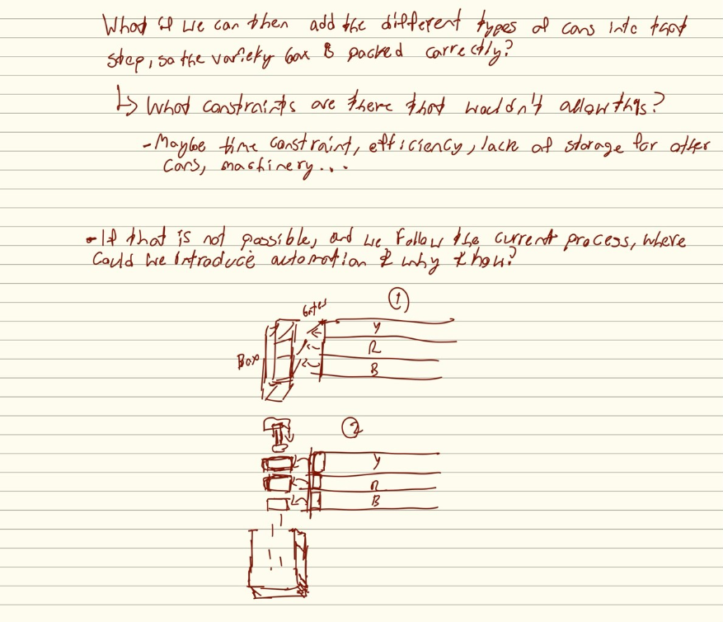

Prototype Brainstorming Ideas After On-Site Visit:
- This is an escapement and package-loading visualization. It shows the ideas of staged release and pushers.
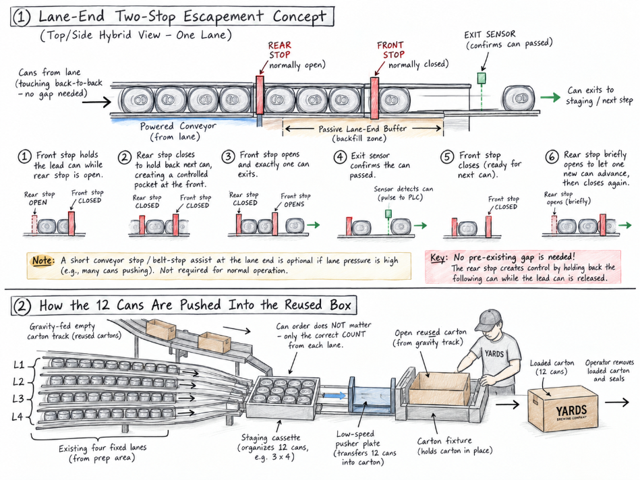

This image shows our Servo-gate exploration idea
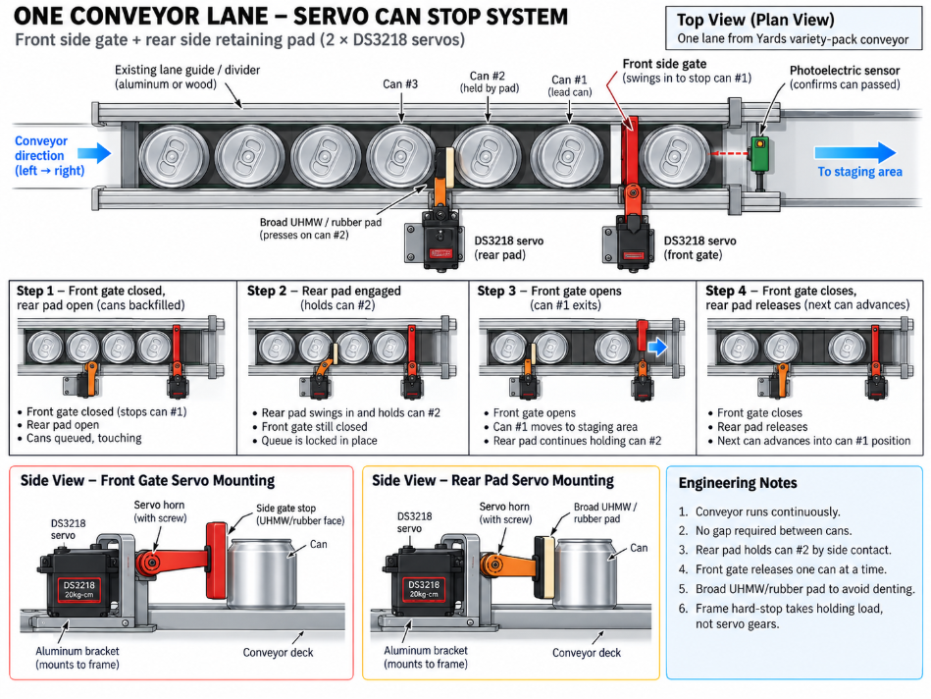

- This is a bird’s-eye/top-down view to show three useful lanes the cans use to go forward through a double-gated section, then toward horizontal carton loading. The fourth physical lane is not currently used at Yards, but it might be in the future.
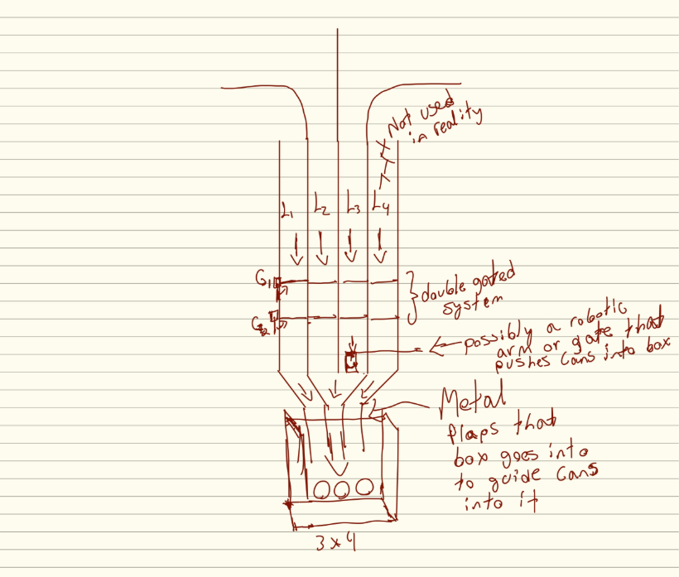

- One of the latest prototype ideas: three active lanes, two parallel gate rows in the same horizontal plane, forward flow toward the package box, and horizontal loading with an optional pusher. The two gates can also be moved to push the cans instead of the pusher. This is still conceptual.

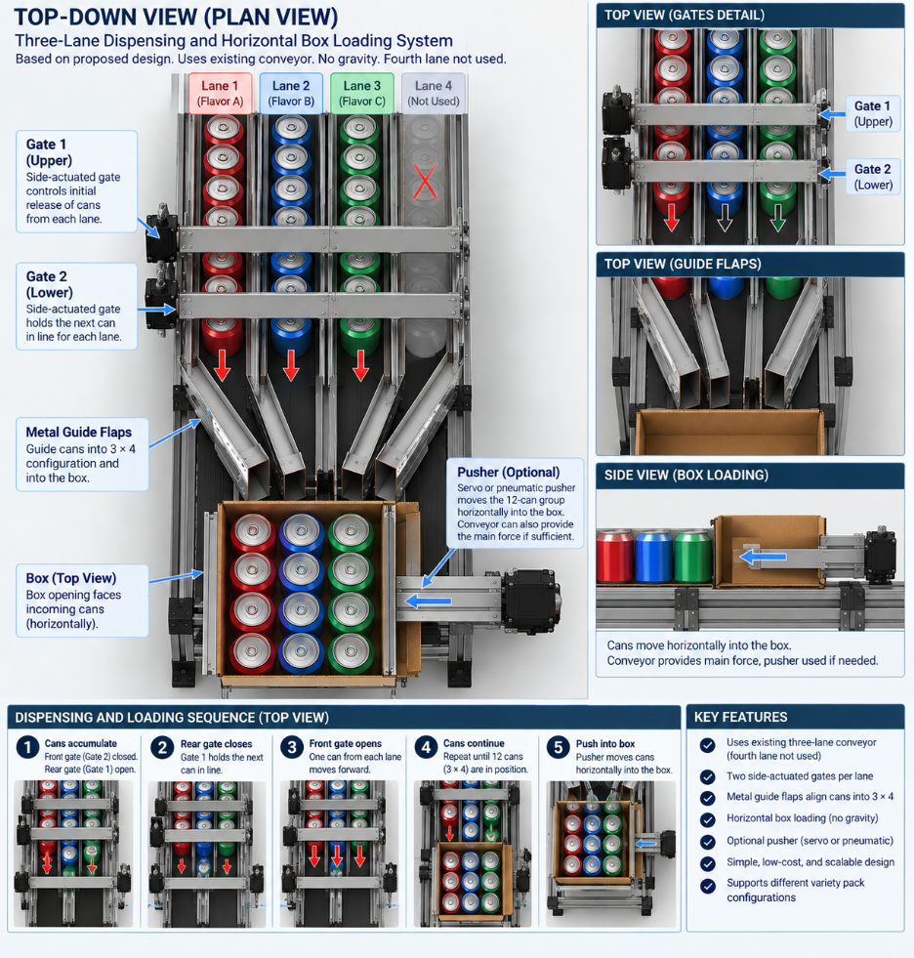
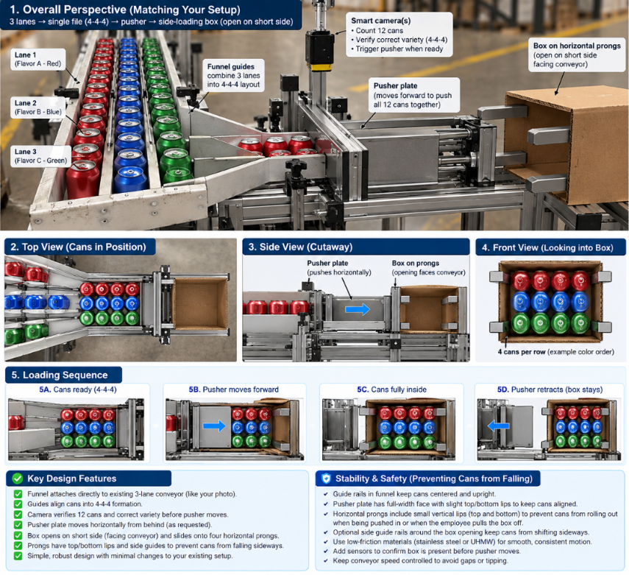
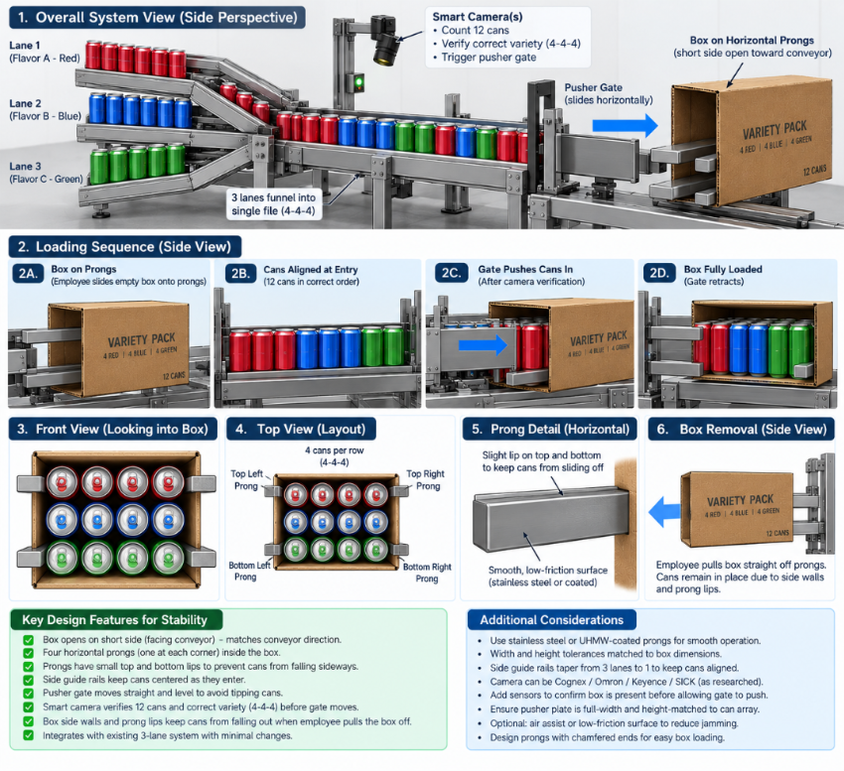

TAB 7: Supporting Notes Decision and Open Items

Additional Yards Brewery Observations
During the Yards Brewery visits, the team collected additional information about the facility, equipment, and production environment. These observations helped the team better understand how the brewery operates but are not directly related to the main variety-pack automation design. They are included here as supporting documentation for the project.

Current Confirmed Yards Support
Mark Jon
- Provide or locate original Kaizen-event drawings and throughput information for the variety-pack line.
- Help clarify the existing system's operating assumptions and capacity.
Neal Goss
- Coordinate with Diesel regarding another production observation visit.
- Help the team understand the existing Switchback/double-gate mechanisms.
- Provide or help source basic mechanical hardware such as gates, brackets, bearings, and related components.
Penn State / Team 1
- Electronics and control components.
- Camera and vision system.
- Software.
- Prototype control logic.
- Integration and testing.

- Unresolved assumptions
Some parts of the prototype are still conceptual and will need to be tested or confirmed. The team currently assumes that enough space will be available for the proposed gate and loading system and that the existing conveyor layout can support the prototype. The final design may need to change after measurements, hardware availability, and testing requirements are confirmed with Yards.

- Follow-up items
The team will continue communicating with Yards as the prototype is developed. Future follow-up will focus on confirming measurements, reviewing the proposed prototype design, determining available hardware, and obtaining any additional information needed for construction and testing. The team will schedule another visit when the variety-pack process is operating so that the proposed system can be compared with the actual workflow.

Information Still Needed
Open item | Why needed | Status
Original Kaizen drawings/data | Establish real baseline throughput and original design calculations | Waiting on Mark
Exact gate-to-box distance | Pusher and dead-plate geometry | Needs measurement
Exact usable conveyor width | Mechanical design | Needs confirmation
Existing escapement dimensions | Avoid reinventing a mechanism Yards already uses | Follow-up visit
Switchback operation | Reference for gate timing and actuation | Follow-up visit
Available hardware list | Determines what we need to purchase | Waiting on Yards
Camera budget | Needed to procure final hardware | Professor Oakes
Box internal/opening dimensions | Needed for funnel/prongs/pusher | Measure
Pusher force/stroke | Needed to choose pneumatic hardware | Prototype/testing
Required minimum cases/hour | Needed to evaluate whether prototype is operationally useful | Kaizen data + Yards

Current Design Decisions
Decision | Current status
Focus only on variety-pack process | Locked
Do not modify main canning/filling process | Locked
Current prototype uses 3 active lanes | Locked for current Yards pack
Use double-gate / escapement principle | Strongly supported
Camera used as independent QC validation | Current direction
Use horizontal carton loading | Locked
Investigate thin stainless guide plates | Current direction
Investigate dead plate + side-discharge pusher | Current direction
Automatic gluing/sealing | Deferred
Exact actuator/controller hardware | Still open

Current Main Risks
The biggest remaining uncertainties are now mechanical rather than conceptual. The project needs to determine whether the 12 cans can be grouped and transferred into the reused carton reliably without denting, jamming, or significantly reducing throughput. Yards admin identified corralling cans into the case as one of the main challenges. The meeting also established that modularity will be important so components can be adjusted or replaced independently.

Next Validation Visit
The next visit should focus specifically on observing the existing double-gate escapement, the Switchback line, the relevant case-erector/pusher mechanism, and the live variety-pack process.
Need measurements to document during next visit:
- gate spacing,
- actuator type,
- timing,
- sensors,
- pneumatic arrangement,
- how back-to-back product is controlled,
- dead-plate geometry,
- pusher stroke,
- box positioning.

